# Second Moment: Variance

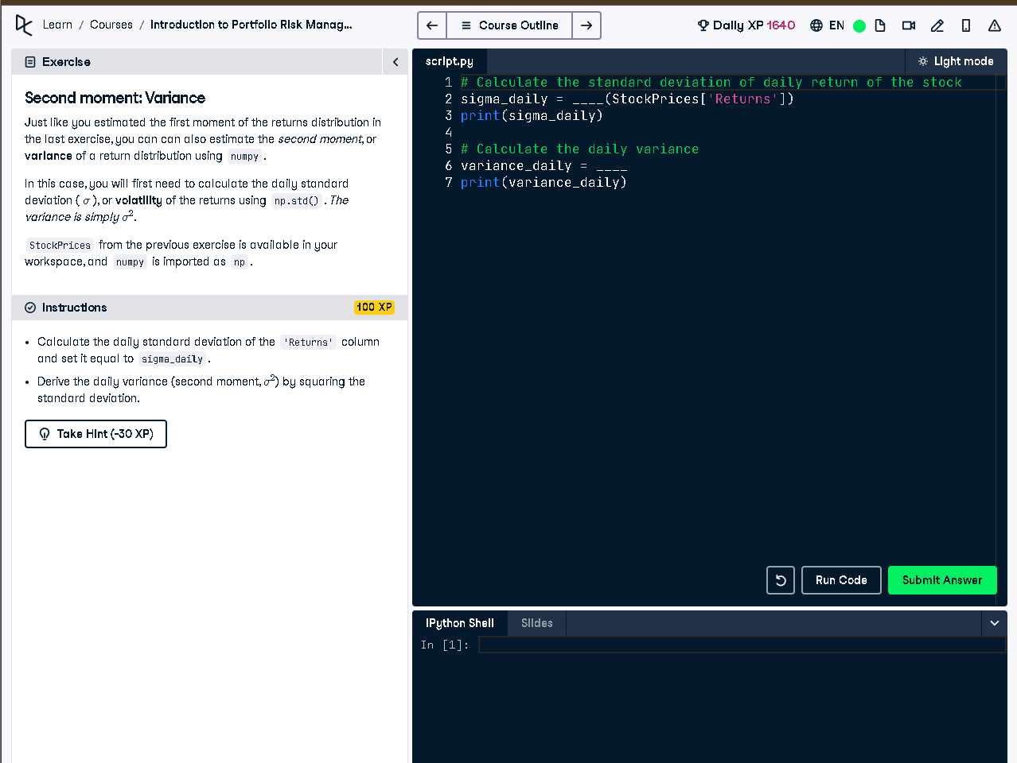

## Python Code

# Calculate the standard deviation of daily return of the stock  
sigma_daily = np.std(StockPrices['Returns'])  
print(sigma_daily)  
  
# Calculate the daily variance  
variance_daily = sigma_daily ** 2  
print(variance_daily)

## Explanation

We calculate how much the daily stock returns change using standard deviation (sigma_daily). Then we square this value to get the daily variance (variance_daily), which measures how spread out the returns are around the average. High variance means more risk.